CHAPTER-1
INTRODUCTION

1. INTRODUCTION
Internal combustion engines are those engines which gives heat during the combustion of fuels in the presence of oxygen in the combustion chamber. After the combustion, the engine undergoes high pressure and high temperature. The conversion of the chemical energy to mechanical energy is done in the internal combustion engine. The transfer of the energy in the combustion chamber takes place with the help of action of piston and valves.
The internal combustion engines are widely used as the high temperature and high pressure can be reduced by the heat sink to the consistent temperature keep the system in running and these engines are used in motorcycle. The mechanism used in the engine is simple reciprocating piston and cylinder system, the movement of the piston in the cylinder makes the area a tight seal, the reciprocating motion of the piston connected to the connecting rod and the crankshaft arrangement, making the reciprocating motion to the rotary motion of the shaft.
The advantages of the internal combustion engines are lower cost, greater mechanical and thermal efficiency, easy to carry or portable.
HISTORY OF ENGINES
The first commercial successful internal combustion engine was created by Etlenne Lenoir in 1859 and next modern engine was created in 1876 by Nikolaus Otto.
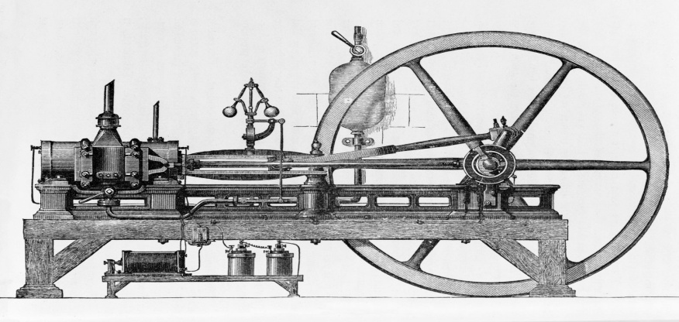
There by the history of internal combustion engines started to change to new models by many scientists and engineers as in 1872 an American George Brayton invented the first liquid fuel internal combustion engine , in 1886 Karl Benz invented the motor vehicle used internal combustion engine, in 1892 Rudolf Diesel developed the first compressed ignition engine[1].
1.2 CLASSIFICATION OF INTERNAL COMBUSTION ENGINES
1. Based on application
- Automobile Engine
- Aircraft Engine
- Locomotive Engine
- Marine Engine
- Stationary Engine
2. Based on basic engine design
- Reciprocating: Single cylinder, Multi-cylinder In-line, V, radial, opposed cylinder, Opposed Piston.
- Rotatory: Single motor, Multi motor
3. Based on operating cycle
- Atkinson (For complete expansion SI Engine)
- Diesel (For the Ideal Diesel Engine)
- Dual (For the Actual Diesel Engine)
- Miller (For Early/Late Inlet valve closing type SI Engine)
- Otto (For the Convectional SI Engine)
4. Based on working cycle
- Four stroke cycle
- Two stroke cycle
  - Scavenging ; direct/crankcase/cross flow; back flow/loop; Uni flow
  - Naturally aspirated or turbocharged
5. Based on Valve/port design and location
- Design of valve/port
  - Poppet valve
  - Rotatory valve
- Location of valve/port
  - T-head
  - L-head
  - F-head
6.Based on Fuel
- Convectional
  - Crude oil derivatives; Petrol, diesel
  - Other sources; coal, bio-mass, tar stands, shale
- Alternative
  - Petroleum derived: CNG, LPG
  - Bio-mass derived: alcohols, vegetable oils, producer gas, biogas and hydrogen
  - Blending
  - Bi-fuel and dual fuel
7. Based on mixture preparation
  - Carburetion
  - Fuel injection
8. Based on ignition
  - Spark ignition
  - Compression Ignition
9. Based on stratification of charge
- Homogeneous Charge
- Stratified charge
  - With carburetion
  - With fuel injection
10. Based on combustion chamber design
- Open chamber: Disc, wedge, hemispherical, bowl-in-piston, bath tub.
- Divided chamber:
  - (For CI) 1. Swirl chamber, 2. Pre-chamber
  - (for SI) 1. CVCC, 2. Other designs
11. Based on cooling system
- Air-cooling system
- Water-cooling system
RECENT ADVANCES IN THE INTERNAL COMBUSTION ENGINES
With continuous refinement of design and implementation of technologies has led internal combustion engines more efficient in recent years. According to Corporate Average Fuel Economy norms and pollution control guidelines, new innovation is necessary to increase mileage and emission of pollution needs to be controlled/reduce by the cars.
We see a new advancement changes in technologies in the future by the automotive industry.
The few technologies which could be conventional in the cars as follows
1. Camless engines: In this, infinite variable valve timing is being offered. With remapping of architecture of engine, we can change valve lift which helps in better performance of engine.
2. DI Turbo Ethanol engine: To increase efficiency of petrol engine as diesel engine, engines will have fuel injection system with direct injection turbo port which helps in higher compression ratios. To have more power E85 Ethanol would be injected to the direct injection system[2].
1.3 Fuel injection system
Fuel injection [3] is the advent of gas in an inner combustion engine, most typically automotive engines, through the manner of an injector.
All diesel engines use gasoline injection by using design. Petrol engines can use fuel direct injection, wherein the gasoline is directly brought into the combustion chamber, or oblique injection where the gas is mixed with air earlier than the consumption stroke.
On petrol engines, gas injection changed carburetors from the Eighties onward. The number one difference among carburetion and gas injection is that fuel injection atomizes the fuel thru a small nozzle underneath excessive pressure, even as a carburetor is based on suction created via consumption air multiplied thru a Venturi tube to attract the gas into the airstream.
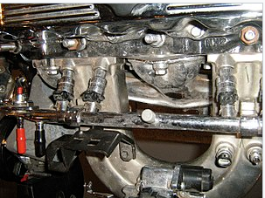
Fig 1.1
Main Objectives
The functional targets for gasoline injection structures can vary. All proportion the important assignment of providing fuel to the combustion manner, however it's miles a layout choice how a selected system is optimized. There are numerous competing goals along with:
• Power output
• Fuel efficiency
• Emissions performance
• Running on opportunity fuels
• Reliability
Benefits
Benefits of fuel injection include smoother and more constant brief throttle reaction, together with at some point of quick throttle transitions, easier cold beginning, greater correct adjustment to account for extremes of ambient temperatures and modifications in air stress, extra strong idling, decreased upkeep needs, and better fuel performance.
It also dispenses for a separate mechanical choke, which on carburetor-ready automobiles have to be adjusted as the engine warms up to regular temperature. Furthermore, on spark ignition engines, (direct) fuel injection has the advantage of being able to facilitate stratified combustion which has not been viable with carburetors.
It is best with the appearance of multi-point fuel injection positive engine configurations which includes inline five-cylinder fuel engines have end up more viable for mass production, as traditional carburetor arrangements with single or twin carburetors cannot offer even gas distribution between cylinders, unless a extra complicated individual carburetor in step with cylinder is used.
1.4 Direct Fuel Injection System
Common rail direct gasoline injection[4] is an immediate fuel injection gadget for diesel engines. It capabilities a excessive-strain (over 100 bar or 10 MPa or 1,500 psi) gas rail feeding solenoid valves, as opposed to a low-stress gasoline pump feeding unit injectors (or pump nozzles). Third-technology not unusual rail diesels now function piezoelectric injectors for expanded precision, with gasoline pressures up to two, 500 bar (250 MPa; 36,000 psi).
High pressure injection gives you power and gasoline consumption blessings over earlier decrease pressure fuel injection, by means of injecting gas as a bigger quantity of smaller droplets, giving a far better ratio of floor region to extent. This offers progressed vaporization from the floor of the fuel droplets and so extra efficient combining of atmospheric oxygen with vaporized fuel delivering more entire combustion.
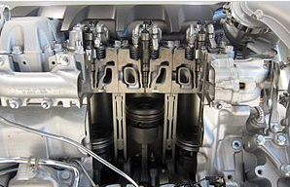
Fig 1.2
Applications
The commonplace rail device is suitable for all types of street motors with diesel engines, starting from metropolis vehicles (which include the Fiat Panda) to executive vehicles (inclusive of the Audi A8). The foremost suppliers of present day common rail structures are Robert Bosch GmbH, Delphi, Denso, and Siemens VDO (now owned through Continental AG)[13].
1.5 Working Principle of CRDI
Solenoid or piezoelectric valves make viable quality electronic manage over the gas-injection time and quantity, and the higher stress that the commonplace rail technology makes available offers higher fuel atomisation. To lower engine noise, the engine's electronic manage unit can inject a small amount of diesel just earlier than the primary injection occasion ("pilot" injection), therefore reducing its explosiveness and vibration, as well as optimising injection timing and quantity for versions in gas pleasant, bloodless starting, and so forth[14]. Some superior commonplace rail gas structures carry out as many as 5 injections in step with stroke.Common rail engines require a very quick to no heating-up time, relying on the ambient temperature, and convey lower engine noise and emissions than older systems[15].
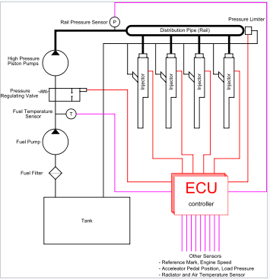
Fig 1.3
Diesel engines have historically used various forms of gasoline injection. Two not unusual types encompass the unit-injection device and the distributor/inline-pump systems[16]. While those older systems offer accurate gasoline quantity and injection timing manage, they are constrained with the aid of several factors:
• They are cam driven, and injection stress is proportional to engine speed. This typically means that the highest injection strain can best be accomplished at the highest engine pace and the maximum possible injection stress decreases as engine velocity decreases. This courting is authentic with all pumps, even those used on commonplace rail structures. With unit or distributor structures, the injection strain is tied to the immediately strain of unmarried pumping occasion and not using a accumulator, for this reason the relationship is extra prominent and troublesome.
• They are limited in the variety and timing of injection occasions that may be commanded at some stage in a single combustion event. While more than one injection activities are viable with those older structures, it is a whole lot more tough and costly to reap.
• For the standard distributor/inline machine, begin of injection takes place at a predetermined pressure (frequently called pop stress) and ends at a predetermined strain. This characteristic results from "dumb" injectors inside the cylinder head which open and close at pressures decided by way of the spring preload carried out to the plunger within the injector. Once the pressure within the injector reaches a predetermined level, the plunger lifts and injection starts.
In not unusual rail systems, a high-stress pump stores a reservoir of gasoline at high strain — up to and above 2,000 bars (200 MPa; 29,000 psi). The time period "not unusual rail" refers back to the reality that every one of the gas injectors are provided through a commonplace gasoline rail that is nothing greater than a strain accumulator where the gas is saved at high stress. These accumulator materials more than one gasoline injectors with high-stress gasoline. This simplifies the purpose of the excessive-stress pump in that it most effective needs to preserve a goal stress (both routinely or electronically managed). The gasoline injectors are normally ECU-controlled. When the fuel injectors are electrically activated, a hydraulic valve (which includes a nozzle and plunger) is automatically or hydraulically opened and gas is sprayed into the cylinders at the desired stress. Since the fuel strain electricity is stored remotely and the injectors are electrically actuated, the injection strain at the start and quit of injection may be very near the pressure within the accumulator (rail), for this reason generating a square injection fee. If the accumulator, pump, and plumbing are sized well, the injection pressure and price will be the same for each of the multiple injection events.

CHAPTER-2
LITERATURE REVIEW

2. LITERATURE SURVEY
2.1 Internal Combustion Engine
2.1.1 Compression Ignition Engine
Hushim et al. [17] the utilization of 1-D reproduction programming program - GT-Power on electronic fuel infusion (EFI) contraption between port-fuel infusion (PFI) and direct infusion (GDI) device for retro fitment rationale of little 125cc 4-stroke gas motor. From the investigation PFI framework was chosen fundamentally dependent on its high brake power, brake torque and brake mean viable weight with low brake explicit fuel utilization.
Wislocki et al. [18] the infusion time in oil motors is equivalent (pressure esteems at present approx. 20 MPa) to the infusion term of diesel fuel. The approach and results of the tests related with the fuel portion division and infusion procedure at the thermodynamic records during the burning framework have been provided through them. The tests were accomplished for a few strategies for fuel portion office at infusion weights of 5, 10 and 20 MPa (changing additionally the hour of the infusion).
Burke et al. [19] Said that gas direct infusion gives diminished motor outflows, extended vitality and expanded fuel monetary framework when contrasted with port fuel infusion (PFI). Diminished discharges are to a great extent a direct result of starting the motor the utilization of exorbitant fuel worry (as much as 150 bar) and infusing into the pressure stroke. During a virus start fuel pressure should be stretched out from raise siphon pressure (regularly 4 to 6 bar) to favored infusion pressure (for the most part 25 bar insignificant). This take a gander at researched the temperature and weight results for the term of motor douse which enable fume and air to shape inside the fuel framework.
Gajbhiye et al. [20] developed an in-chamber gas direct infusion (GDI) motor joining novel ignition innovation which incorporates the upstanding legitimately ports to create tumble movement, the electromagnetic whirl injector to perceive enhanced splash scattering and atomization and the minimized cylinder hole to keep up charge stratification.
Duygu İPCİ et al [21] the blended dynamic and thermodynamic analysis of a 2 -stroke internal combustion engine was accomplished. The variant of the warmth, given to the working fluid all through the heating method of the thermodynamic cycle, became modeled with the Gaussian function. Variations of numerous engine overall performance parameters with engine pace and charging stress were tested. The brake thermal efficiency, cooling loss, friction loss and exhaust lack of the engine were anticipated as approximately 37%, 28%, 4 %, and 31% respectively for 3000 rpm engine velocity and 1 bar charging stress.
Archer et al. [22] advanced air-assisted Synerject Direct Injection (aSDI) for 2-stroke engines and the alternative Synerject digital Port Injection (SePI) for 4-stroke engines. Both structures are intended for utility on small motors fitted with small 1 – 2 cylinder fuel engines of displacement 50 – 250 cm3 according to cylinder. They suggested that tremendous reduction in small vehicle gasoline intake & emission are to be had, thru application of the currently added air-assisted synerject direct injection system to 2-stroke engine & synerject electronic port injection machine to four-stroke engines.
Hunicz et al. [23] used direct injection contolled car-ignition (CAI) unmarried-cylinder research engine for fuel combustion. CAI operation become achieved with use of the poor valve overlap (NAV) approach and internal exhaust gasoline re-stream (EGR). Experiments have been done at unmarried injection and break up injection, wherein a few quantity of fuel turned into injected close to pinnacle dead centre (TDC) during NVO c program language period, and the second injection was carried out with variable timing.
B. Jafar et al. [24] the primary challenge of diesel engines development is simultaneous nitrogen oxides and soot emissions reduction with out the thermal performance drop. Hence, extraordinary combustion principles have to be investigated to attain most excellent emission and overall performance situations in diesel engines with out high priced aftertreatment systems. The contemporary research also supports via 3D-CFD simulation coupled with the chemical kinetics mechanism for special research. Based at the consequences, increasing the premixed ratio of herbal gasoline from 50% to 90% causes the combustion shifts toward the enlargement stroke.
V. Mikita et al.[25] There may be numerous evaluation methods for taking gasoline samples. Drivers keep in mind the fuel exceptional assessment specific strategies especially treasured. Working out a new method like this is at gift additionally supported by means of the electronic manage gadget of the engine and using virtual diagnostic gadgets. Creating and imposing the gas satisfactory evaluation express method requires a large amount of attempt. It includes the assessment and analysis of the fuels bodily and chemical parameters, designing the simulation fashions of the engine combustion system pressure and temperature and wearing out the manipulate checking out.
Dinesh Kumar Soni et al[26] The essential targeted on comparison of diesel and diesel-water mixture on emissions and performance parameters of the diesel engine. The emission parameters which includes NO, CO and soot are investigated numerically by the usage of commercially available CFD software AVL FIRE.

2.1.2 Spark Ignition Engine
Amin Mahmoudzadeh Andwari et al [27] A trial investigate is performed to dissect the effect of using EGR techniques, comprising of Internal and External EGR, on ignition fizzling predominance, burning parity and fumes discharges utilizing a solitary chamber - stroke SI motor at sitting, low and mid-load circumstances. From the outcomes, it is found for the explanation that normal in-chamber temperature is expanded, due to utilizing EGRs, motor's low and mid-load anomalous burnings (failure to discharge) and fumes outflows are strikingly suppressed and practically all of fizzle cycles wiped out contingent upon the extent of EGRs.
Ravikumar M et al [28], To diminish the searching issues by building up another model of two-stroke sparkle start motor. This adaptation permits a progression of clean air through admission valves situated at the most reduced of the chamber and leave consumed gases by means of fumes ports arranged at the highest point of chamber. The fumes ports are shut by utilizing the cylinder as it moves towards to base of the chamber following which gas is infused limiting the plausibility of blending of fuel with active fumes gases.

2.1.3 Common Rail Direct Injection

Sellnau et al. [29] advanced a gasoline compression-ignition combustion engine for complete-time operation over the speed-load map. Low-temperature combustion changed into accomplished the usage of multiple overdue injection (MLI), intake raise, and slight EGR for excessive efficiency, low NOx, and low particulate emissions. Design of experiments and reaction surface models have been used to evaluate injection techniques, injector designs and numerous valve carry profiles throughout the rate-load running variety.
Wang et al[30] The prototype of torque which was based on the control algorithm was used in V-cycle of common rail diesel engine was developed from the existing model from the torque model along with feed forward model engine and feedback correction of error. The feasibility, reliability and optimization of the engine was proved on engine and reached EURO III standards.
Shijie et al[31] The manipulate methods of frequent rail stress through control charge of coming back into glide are studied. The manage circuit and coil valve are trial-manufactured. The strain of frequent rail managed by suggests that of trial-manufactured coil valve are tested in test-bed. The results show that the gap time of Trial-manufactured coil valve is one.1 ms, and its time of day is zero.9 ms. it will fulfill the needs of frequent rail system.
Hanbao et al[32] Based on internal-combustion engine set with common rail, the multi-injection methods common rail internal-combustion engine work is ready up with metallic element take a glance at system. During this work, the influences of optimized multi-injection methods to internal-combustion engine performances are studied. The check outcomes exhibit that by the usage of multi-injection methods, the internal-combustion engine exhaust temperature will minimize 50°C, and noises will minimize 15dB, and emission improve clearly.

2.2 Computational Fluid Dynamics Analysis On Engines
O P Saw et al [33] to comprehend the effect of sparkle attachment and fuel injector region at the blend training in a 4-stroke, 4-valve and divider guided GDI motor working underneath a stratified situation by utilizing the utilization of computational liquid elements (CFD) investigation. All the CFD recreations are completed at a motor speed of 2000 fire up/min., and pressure proportion of 10.6, at a general proportionality proportion (ER) of roughly 0.65.
Y Karaya et al [34] The examination is done on a 4-stroke divider guided GDI motor the utilization of computational liquid elements (CFD). The splash separation rendition utilized is approved with the to be had test impacts from the writing to the amount practical. The examination is practiced for 4 cylinder profiles viz., balance pentroof with counterbalance bowl (OPOB), level cylinder with balance bowl (FPOB), balance pentroof with balance scoop (OPOS) and willing cylinder with balance bowl (IPOB) furnished in a motor outfitted with a six-opening injector with the split infusion proportion of 30:70.
T.N.C. Anand et al [35] Computational Fluid Dynamics reproductions are accomplished to analyze blending planning in the admission complex of a little motor with Port Fuel Injection. Information from laser-put together absolutely tries different things with respect to two injectors are utilized as contributions to the shower sub-model. The outcomes screen ventured forward in-chamber fuel conveyance when the splash is coordinated onto the admission valve.
Dr. Abdul Siddique et al. [36] The geometry of the combustion chamber Is one of the element Effecting the efficiences of C.I Engine (Diesel Engine). There are diverse engines used for agriculture cause out of that MINI-PETER Diesel engine is commonly utilized in present days. In this gift work the changed geometries of MINI-PETER diesel engine is as compared with the baseline information. The effect of geometry on the parameters like CO, CO2, NOX, HC and smoke density are studied. From the effects its miles concluded that the turbulence effect in the modified geometry is better than the baseline geometry parameters.
J. Krishnaraj et al. [37] A computational version of IC engine is modeled and computational fluid dynamic analysis has completed with the aid of using FLUENT. In the analysis, combustion parameters like fluid flow, mixing, turbulence and back pressure is analyzed the usage of CFD. Combustion performance, temperature characteristics, pressure and emission parameters of CO, HC and NOx can be recorded and analyzed at numerous drift fees of hydrogen. In this undertaking a methodology of diverse proposed designs of piston heads is modelled and primarily based at the boundary conditions that model is analyzed.
P. Vijayakumaran et al.[38] The Common-rail injection system has allowed reaching a more bendy gasoline injection Control in DI-diesel engines via permitting a unfastened mapping of the start of injection, Injection pressure, fee of injection. All those advantages have to be benefit by using putting in this tool in combustion chambers born to paintings with the traditional distributor and in-line-pump injection systems. Their design was aimed to enhance air-gas mixing and therefore they had been characterized with the aid of the adoption re-entrant bowls. All the other applicable parameters namely compression ratio, most diameter of the bowl, squish clearance and injection rate were saved regular.
K. Abay et al. [39] flow and combustion characteristics of a diesel engine are investigated with the aid of the use of Computational Fluid Dynamics (CFD). Whole engine components are modeled and analyses are performed for entire pace range of the engine. Calculated crank perspective structured pressure and temperature values are used as boundary circumstance for reactive 3D CFD simulations. Reactive CFD simulations are achieved with 45° area geometry for the duration that each valves are closed. In reactive simulations, RNG okay-ε and Standard ok- ε models are used to symbolize turbulence float discipline.
H.Sushma et al.[40] The studied about the effect of piston configurations on in- cylinder waft. Here a single cylinder direct injection diesel engine is used for look at. For obtaining swirl intensity helicalspiral combination inlet manifold is used. In the prevailing paintings, a look at at the impact of various piston configurations on air movement and turbulence within the cylinder of a Direct Injection (DI) diesel is executed using Computational Fluid Dynamics (CFD) code Fluent 13. 3 dimensional models of the manifolds, pistons and the cylinder is created in CATIA V5 and meshed using the pre-processor Hypermesh 10.0.

CHAPTER-3
PROBLEM DESCRIPTION & METHODOLOGY

3. PROBLEM DESCRIPTION & METHODOLOGY
3.1. Air Fuel interaction in cylinder
To ignite the air/fuel mixture into the combustion chamber of a thermal engine, it's necessary that an electric discharge (spark) to be triggered between the electrodes of a plug. In order to extend power of the engine is needed to obtain for every cycle a quick and complete burning of the mixture that conjointly involves supply the spark with the maximum amount attainable of current. Within the same time, to facilitate and to “speed-up” the fuel burning we'd like to have a lot of consistent volume of plasma and conjointly to increase the interaction (contact) surface between plasma and air/hydrocarbons mixture. Supported these assumptions an explicit number of different ideas are projected however they're still remaining for the most majority to tough to be enforced on engines [40]. From this class we are able to bear in mind the ignition devices that use different forms of discharges than a classical plug such: periodic optical device [41], corona discharges [42] or GlidingArc discharges [43].

3.1.1. Modeling
Pro/ENGINEER Wildfire is the standard in 3D product design, featuring industry-leading productivity tools that promote best practices in design while ensuring compliance with your industry and company standards. Integrated Pro/ENGINEER CAD/CAM/CAE solutions allow you to design faster than ever, while maximizing innovation and quality to ultimately create exceptional products.
Customer requirements may change and time pressures may continue to mount, but your product design needs remain the same - regardless of your project's scope, you need the powerful, easy-to-use, affordable solution that Pro/ENGINEER provides.
Pro/Engineer Wildfire Benefits
•Unsurpassed geometry creation capabilities allow superior product differentiation and manufacturability
•Fully integrated applications allow you to develop everything from concept to manufacturing within one application
•Automatic propagation of design changes to all downstream deliverables allows you to design with confidence
•Complete virtual simulation capabilities enable you to improve product performance and exceed product quality goals
•Automated generation of associative tooling design, assembly instructions, and machine code allow for maximum production efficiency
Pro ENGINEER can be packaged in different versions to suit your needs, from Pro/ENGINEER Foundation XE, to Advanced XE Package and Enterprise XE Package, Pro/ENGINEER Foundation XE Package brings together a broad base of functionality. From robust part modeling to advanced surfacing, powerful assembly modeling and simulation, your needs will be met with this scalable solution. Flex3C and Flex Advantage Build on this base offering extended functionality of you’re choosing.

Different Modules In Pro/Engineer
- Part Design
- Assembly
- Drawing
- Sheetmetal

3D Model
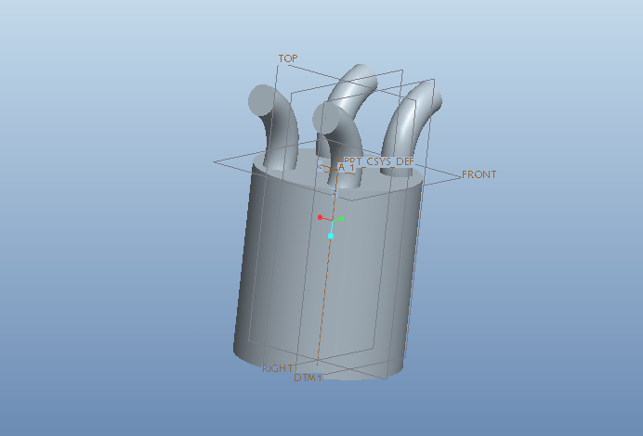
Fig 3.1

2D Model
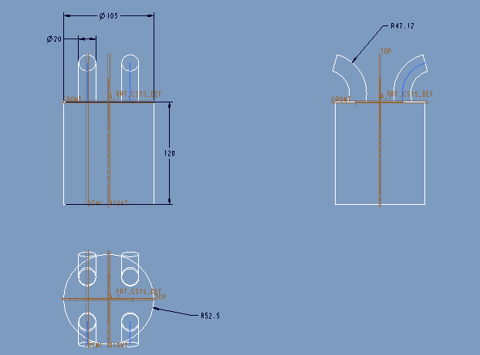
Fig 3.2
3.1.2. Grid independence & Validation study
Computational fluid dynamics, usually abbreviated as CFD, is a branch of fluid mechanics that uses numerical methods and algorithms to solve and analyze problems that involve fluid flows. Computers are used to perform the calculations required to simulate the interaction of liquids and gases with surfaces defined by boundary conditions. With high-speed supercomputers, better solutions can be achieved. Ongoing research yields software that improves the accuracy and speed of complex simulation scenarios such as transonic or turbulent flows. Initial experimental validation of such software is performed using a wind tunnel with the final validation coming in full-scale testing, e.g. flight tests.
At coarse method
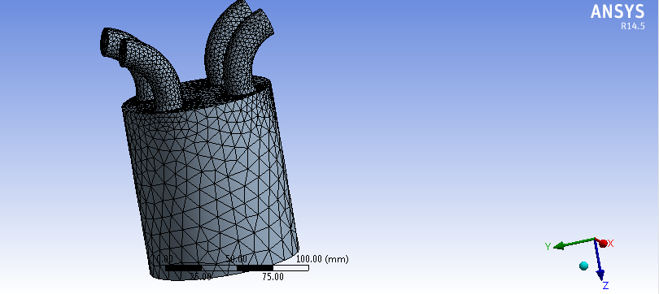
Fig 3.3

Meshing was done with the help of ANSYS mesh. Maximum face size is set to 1.20 for finer mesh. Grid independence tests were performed with three different grids of elements. 

At Medium Method
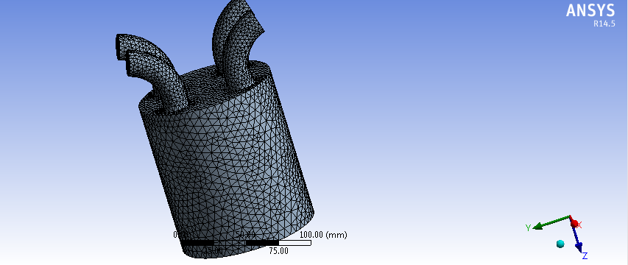
Fig 3.4

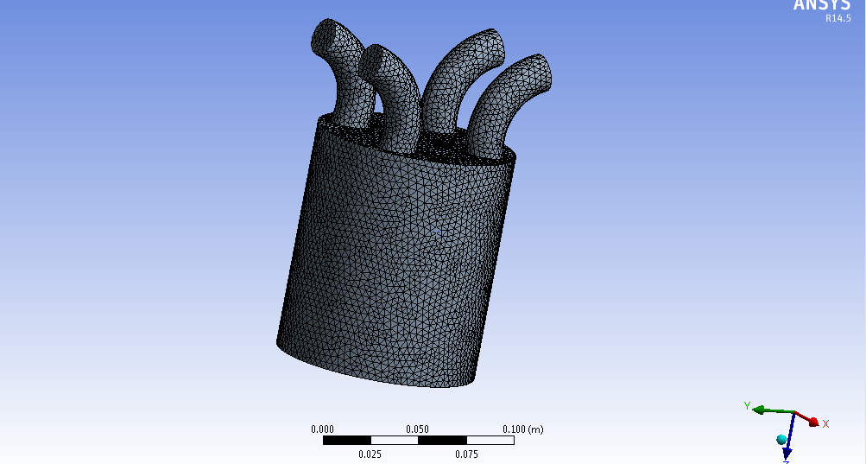
Fig 3.5
The model is designed with the help of pro-e and then import on ANSYS for Meshing and analysis. The analysis by CFD approach is used in order to calculating pressure profile and temperature distribution. For meshing, the fluid ring is divided into two connected volumes. Then all thickness edges are meshed with 360 intervals. A tetrahedral structure mesh is used. So the total number of nodes and elements is 21264and 109297.

Governing Equations
General Form:
Continuity Equation:
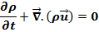
Momentum Equation:
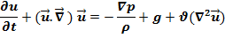
Where,
- ρ is the density,
- u is the flow velocity,
- ∇ is the divergence,
- P is the pressure,
- t is the time,
- is kinematic viscosity,
- g is body accelerations like gravity, internal accelerations, electrostatic accelerations and so on.
The steady state which is time independent, the transient operator,is neglected in both the equations.
Thrust Formulation
The thrust equation for ramjets and scramjets contain three terms: gross thrust, ram drag, and a pressure correction. If the free stream conditions are denoted by a "0" subscript and the exit conditions by an "e" subscript, the thrust F is equal to the mass flow rate m dot times the velocity V at the exit minus the free stream mass flow rate times the velocity plus the pressure p difference times the nozzle exit area:
Where,
- is the mass flow rate at the exit
- is the velocity at the exit condition
- is the mass flow rate at the free stream conditions
- is the velocity of the free stream
- is the dynamic pressure at the exit
- is the freestream dynamic pressure
- is the exit area
- Aerodynamicists often refer to the first term (exit mass flow rate times exit velocity) as the gross thrust, since this term is largely associated with conditions in the nozzle.
- The second term (free stream mass flow rate times free stream velocity) is called the ram drag. This term can be quite large for scramjet engines.
- For ramjets and scramjets, the nozzle exit velocity is supersonic, and the exit pressure depends on the area ratio between the throat of the nozzle and the exit of the nozzle. Only for a unique design condition is the exit pressure equal the free stream static pressure. For all other conditions, we must include the third term of the thrust equation (exit pressure minus free stream pressure times the exit area). This pressure correction is usually small compared to the first term of the thrust equation. But for completeness, this term is usually included in the gross thrust.

Methodology
In all of these approaches the same basic procedure is followed.
During preprocessing
- The geometry (physical bounds) of the problem is defined.
- The volume occupied by the fluid is divided into discrete cells (the mesh). The mesh may be uniform or non-uniform.
- The physical modeling is defined – for example, the equations of motion + enthalpy + radiation + species conservation
CFD ANALYSIS
→→ Select mesh on work bench → right click →edit → select mesh on left side part tree → right click → generate mesh →

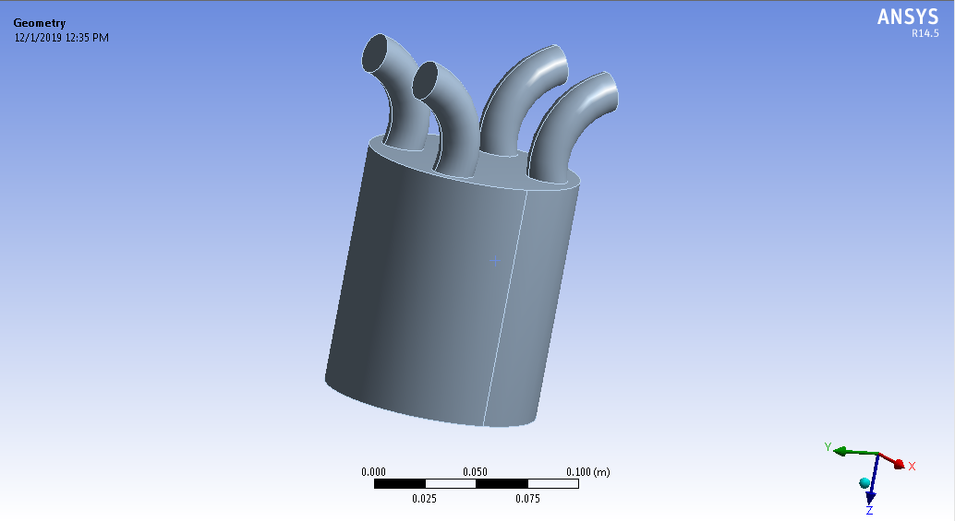
Fig 3.6
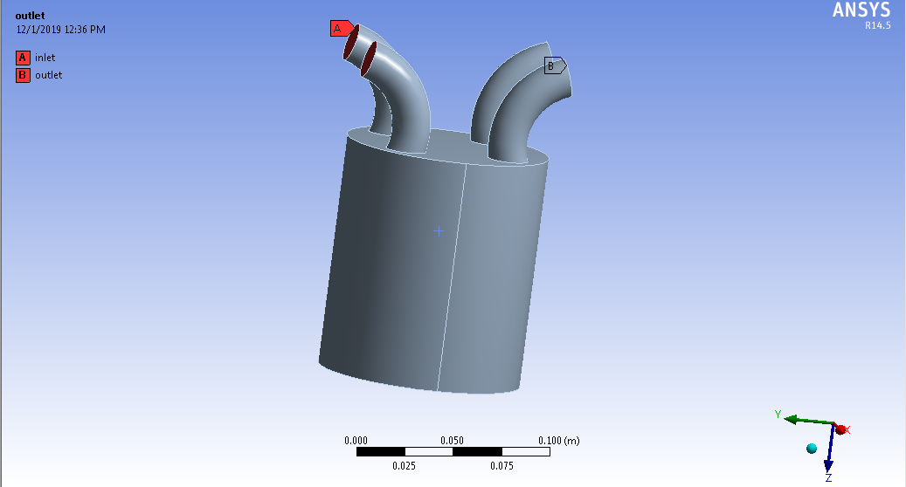
Fig 3.7
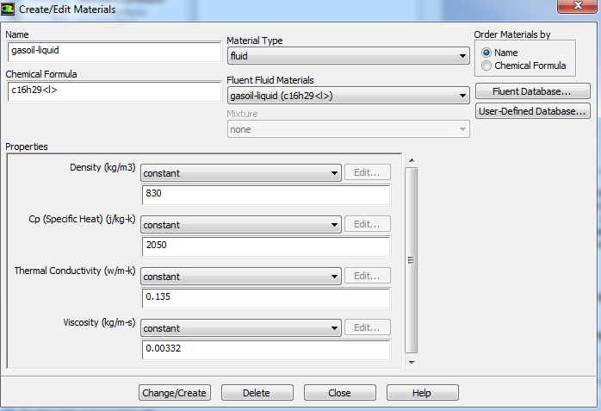
Fig 3.8

3.1.3 Boundary conditions
Boundary conditions>inlet>enter required inlet values-at engine speed-1500 rpm –mass flow arte is 0.0011054 kg/sec
Solution > Solution Initialization > Hybrid Initialization >done
Results:
edit>select contours>ok>select location (inlet, outlet, wall.etc)>select pressure>apply
AT ENGINE SPEED-1500 RPM
Pressure counters
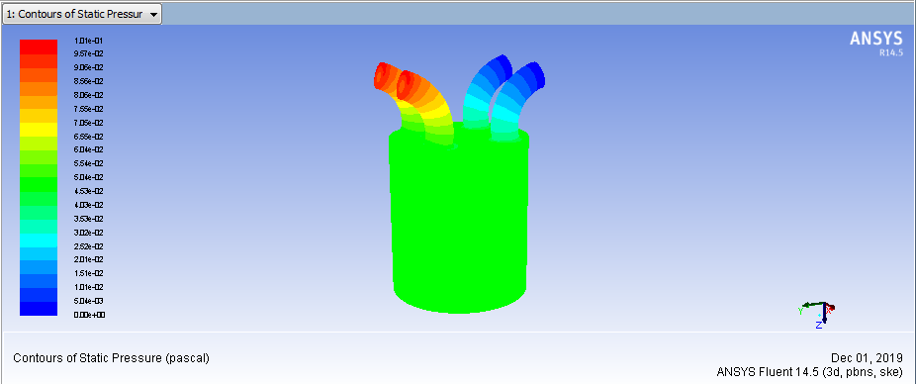
Fig 3.9

According to tha counter plot, the maximum pressure at at inlet valves and minimum pressure at outlet valves.
The maximum pressure is 1.01e+02 Pa and minimum pressure is 6.04e-03.
Velocity counters
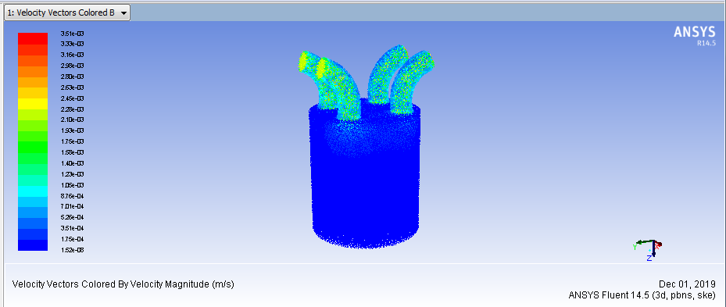
Fig 3.10
According to tha counter plot, the maximum velocity at at inlet and outlet valves and minimum velocity at chamber.
The maximum velocity is 3.54e+03 m/s and minimum pressure is 1.15e+02 m/s.
Heat transfer coefficient
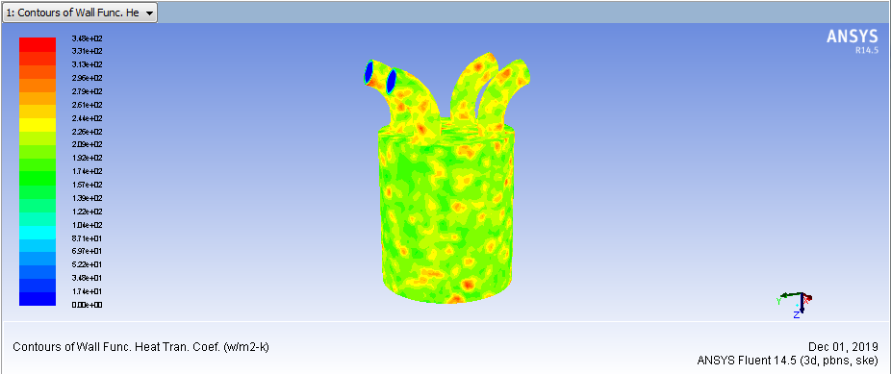
Fig 3.11
According to tha counter plot, the maximum heat transfer coefficient at combustion chamber and outlet valves and minimum heat transfer coefficient at chamber.
The maximum heat transfer coefficient is 3.44e+02 m/s and minimum pressure is 1.74e+01 m/s.

Turbulent Kinetic Energy
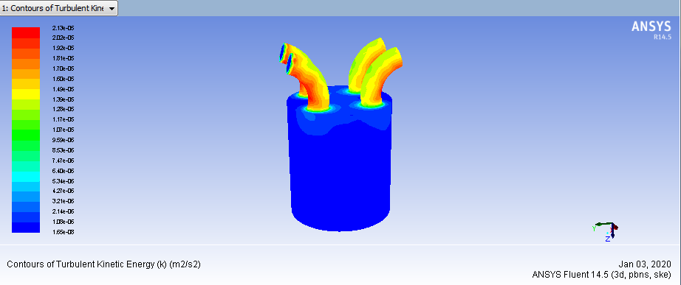
Fig 3.12
Mass flow rate
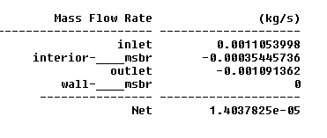
Heat transfer rate
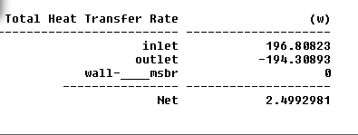

At engine speed -2000 RPM
Pressure counters
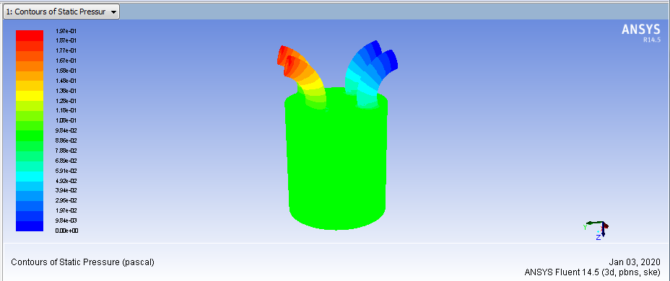
Fig 3.13
Velocity counters
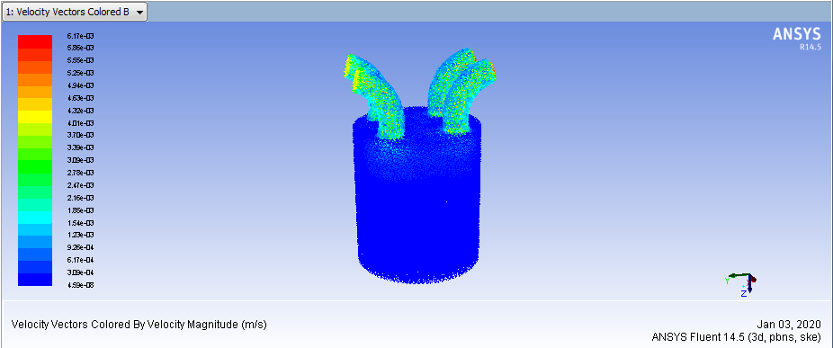
Fig 3.14

Heat transfer coefficient
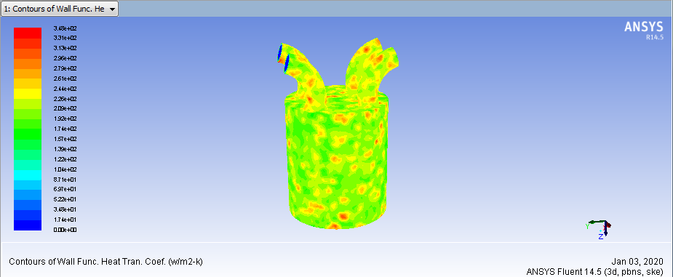
Fig 3.15
Turbulent kinetic energy
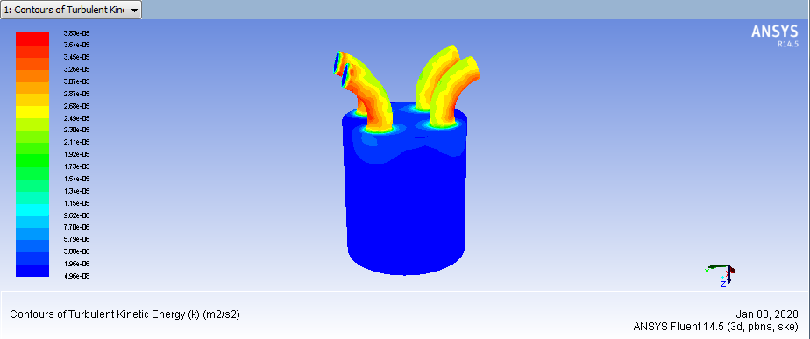
Fig 3.16

Mass flow rate
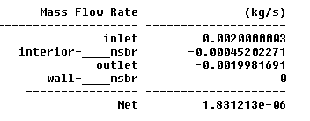
Heat transfer rate
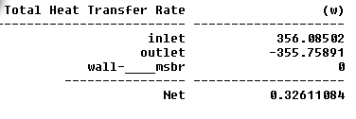
AT ENGINE SPEED-2500 RPM
Pressure counters
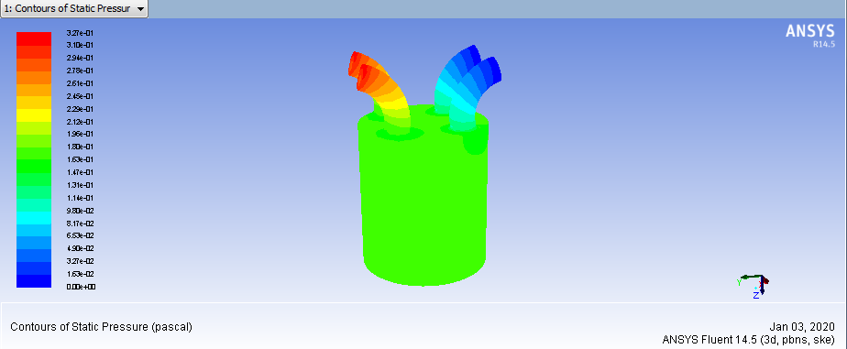
Fig 3.17
Velocity counters
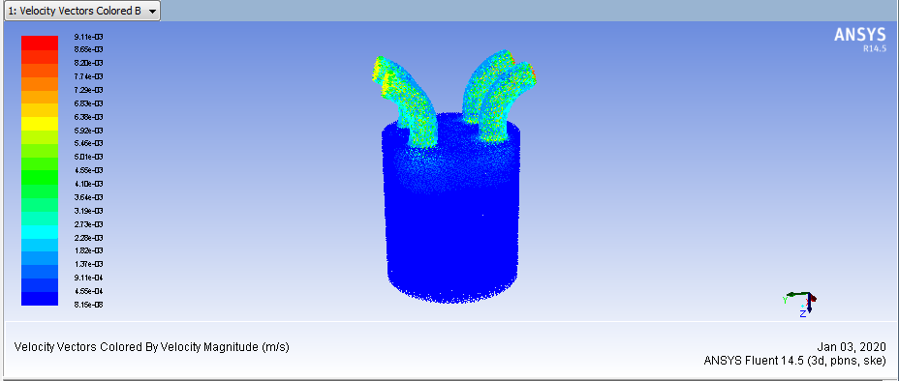
Fig 3.18

Heat transfer coefficient
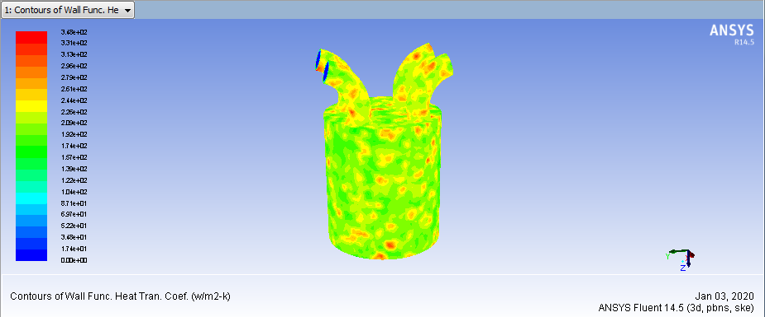
Fig 3.19
Turbulent kinetic energy
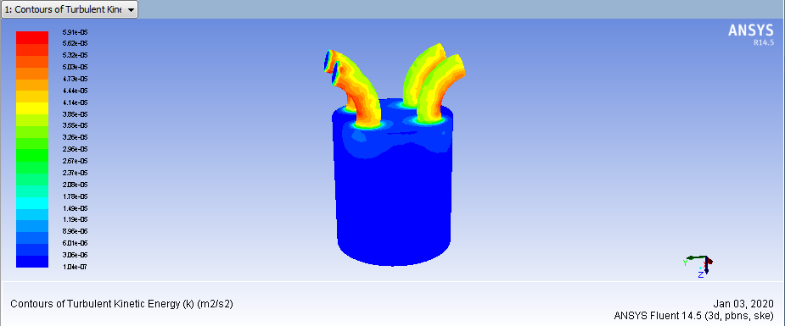
Fig 3.20
Mass flow rate
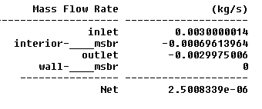
Heat transfer rate
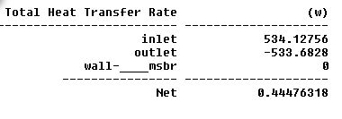

Results table
Engine speed(Rpm) | Pressure (Pa) | Velocity (m/sec) | Heat transfer coefficient | Turbulent kinetic energy | Mass flow rate(kg/sec) | Heat transfer rate(w)
1500 | 1.04e-01 | 3.31e-03 | 3.35e+02 | 2.13e-05 | 1.403e-05 | 2.4992981
2000 | 1.57e-01 | 6.17e-03 | 3.48e+02 | 3.83e-01 | 1.8312e-06 | 0.32611084
2500 | 3.27e-01 | 9.11e-03 | 3.52e+02 | 5.91e-05 | 2.500e-06 | 0.44476318
Table 3.1

Graphs
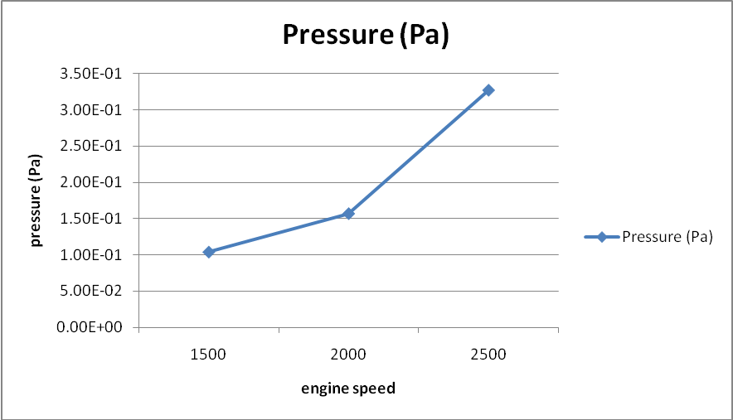
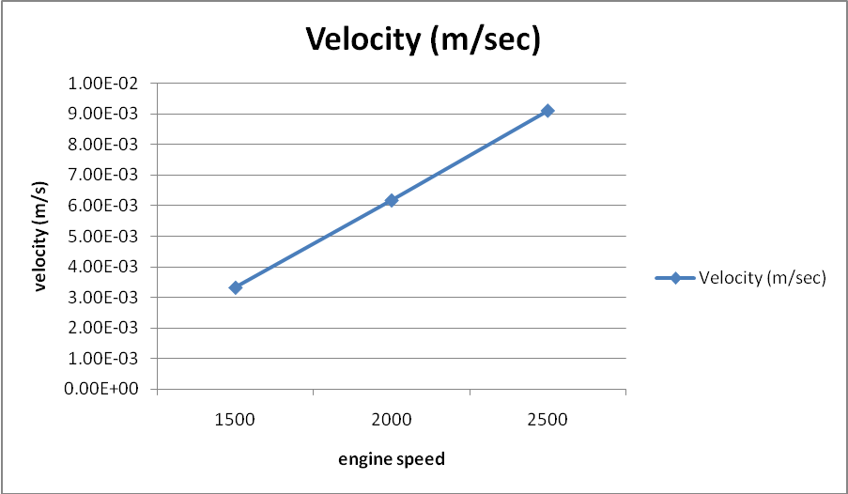

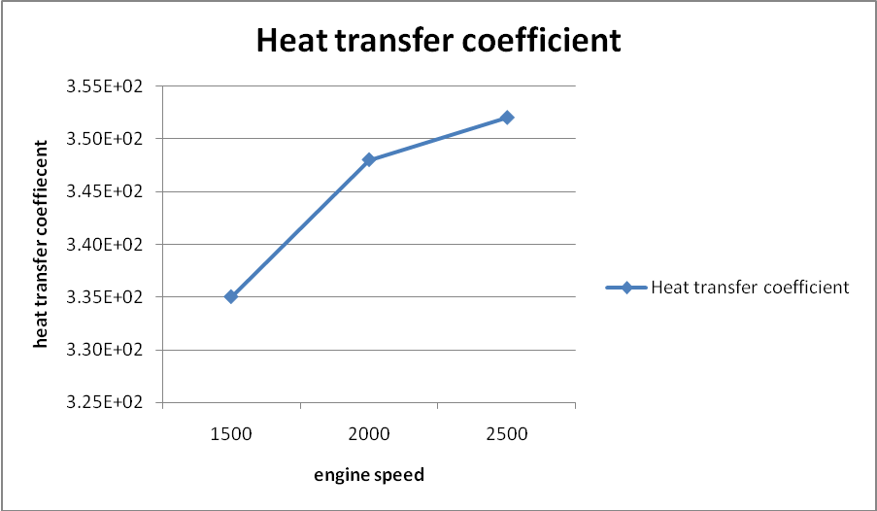
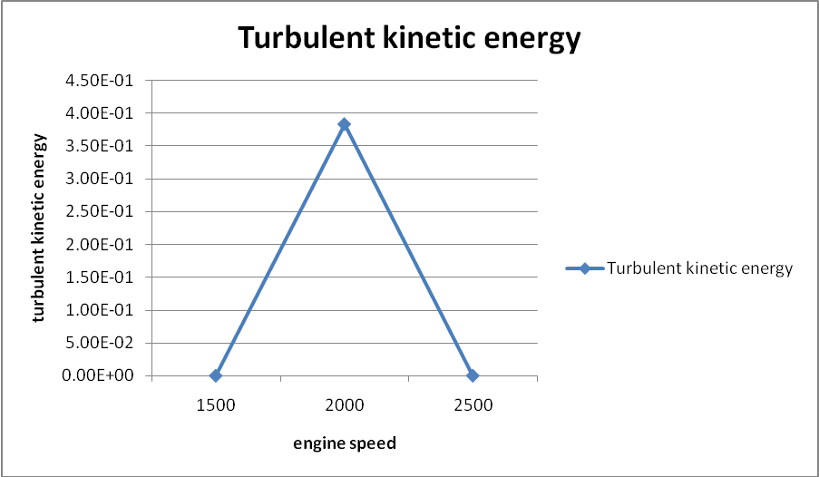

CHAPTER-4
REFERENCES

4. References
[1]. https://en.wikipedia.org/wiki/Fuel_injection.
[2]. https://en.wikipedia.org/wiki/Hybrid_powertrain.
[3]. https://en.wikipedia.org/wiki/Fuel_injection.
[4]. https://en.wikipedia.org/wiki/Gasoline_direct_injection.
[5]. https://en.wikipedia.org › wiki › Common_rail.
[6]. https://www.bhpplus.co.uk/Technical-Info.html
[7]. https://www.manualdownload.co/index.php?app=ccp0&ns=prodshow&ref=jeep-grand-cherokee-wk-wh-workshop-manual
[8]. https://en.wikipedia.org/wiki/Cooper_Bessemer
[9]. http://hiodigital.000webhostapp.com/hhbo1ddx/common-rail-diesel-ecu.html
[10]. https://en.wikipedia.org/wiki/Opposed-piston_engine
[11].https://www.jchps.com/specialissues/2017%20Special%20Issues%2013/20170920_021520_AFM17193.pdf
[12]. https://en.wikipedia.org/wiki/Common_rail
[13]. https://www.manualdownload.co/index.php?app=ccp0&ns=prodshow&ref=jeep-grand-cherokee-wk-wh-workshop-manual

[14]. https://europe.autonews.com/article/20061113/ANE/61109031/injector-wars-piezo-vs-solenoid
[15]. https://pdfslide.net/documents/common-rail-nef-engines-cnh.html
[16]. https://en.wikipedia.org/wiki/Common_rail#Principles.
[17] M. F. Hushim, A. J. Alimin, H. Selamat, and Mohd T. Muslim "PFI System for Retrofitting Small 4-Stroke Gasoline Engines",International Journal of Environmental Science and Development, Vol. 4, No. 4, pp. 375-378, 2013.
[18] K. Wislocki, I. Pielecha, D. Maslennikov and J. Czajka "Thermodynamic Aspects of CombustionIn Gasoline Engines Fitted with a Multiple Fuel Injection",Journal of KONES Power train and Transport, Vol. 18, No. 4, pp.543-553, 2011.
[19] D. Burke, D. Foti, J. Haller and W. J. Fedor "Fuel Rail Pressure Rise during Cold Start of aGasoline Direct Injection Engine", SAE International Journal, doi:10.4271/2012-01-039, 2012.
[20] P. K. Gajbhiye and S. P. Chincholka "A Review on Electronically Assisted Gasoline Direct Injection 4-Stroke Single Cylinder Engine System",International Journal of Science and Research (IJSR),Vol. 2, No. 6, 2013.
[21] Duygu İPCİ*, Halit KARABULUTa aGazi University Technology Faculty Automotive Engineering Department (Geliş / Received : 27.06.2015 ; Kabul / Accepted : 24.07.2015) Dynamic and Thermodynamic Examination of a TwoStroke Internal Combustion Engine Duygu İPCİ, Halit KARABULUT / POLİTEKNİK DERGİSİ, Politeknik Dergisi, 2016; 19 (2) : 141-154.
[22] M. Archer and G. Bell “Advanced Electronic Fuel Injection Systems –An Emissions Solution for both 2- and 4-stroke Small Vehicle Engines”, SIAT26, pp.1-22, 2001.
[23] J. Hunicz and P. Kordos “ An Experiment study of Fuel Injection strategies in CAI Gasoline Engine”, Experimental Thermal and Fluid Science , Elsevier, vol.35, pp.243-252, 2011.
[24] B. Jafari*a, H. Khatamnejadb, M. H. Shahavia, D. D. Ganjica Faculty of Engineering Modern Technologies, Amol University of Special Modern Technologies (AUSMT), Amol, Iran Simulation of Dual Fuel Combustion of Direct Injection Engine with Variable Natural Gas Premixed Ratio IJE TRANSACTIONS C: Aspects Vol. 32, No. 9, (September 2019) 1327-1336
[25] V. Mikita1, J. Roots2 and J. Olt1 1Institute of Technology, Estonian University of Life Sciences, Kreutzwaldi 56, EE51014, Tartu, Estonia; e-mail: villu.mikita@emu.ee, Simulation model of the combustion processes of a diesel engine Agronomy Research Biosystem Engineering Special Issue 1, 157-166, 2012
[26] Dinesh Kumar Soni1*, Rajesh Gupta2 1*Department of Mechanical Engineering, MANIT, Bhopal, INDIA Comparison of performance and emission characteristics of diesel and diesel-water blend under varying injection timings International Journal of Engineering, Science and Technology Vol. 7, No. 4, 2015, pp. 49-59.
[27] Amin Mahmoudzadeh Andwari 1,2,3,* , Apostolos Pesyridis 1 , Vahid Esfahanian 2 and Mohd Farid Muhamad Said Center for Advanced Powertrain and Fuels Research (CAPF), Department of Mechanical, Aerospace and Civil Engineering, Brunel University London, London UB8 3PH, UK Combustion and Emission Enhancement of a Spark Ignition Two-Stroke Cycle Engine Utilizing Internal and External Exhaust Gas Recirculation Approach at Low-Load Operation Energies 2019, 12, 609; doi:10.3390/en12040609 www.mdpi.com/diary/energies.
[28] Ravikumar M.1 , Mohanraj T.2 And Venkatesan D.2 1bannariamman Institute Of Technology, Sathyamangalam, India 2 School Of Mechanical Engineering Sastra University, Thanjavur, India Improved Design Of Air Flow For A Two Stroke Internal Combustion Engine To Promote Cleaner Combustion Vol. 13, No. 5, March 2018 Issn 1819-6608 Arpn Journal Of Engineering And Applied Sciences.
[29] M.C. Sellnau, J. Sinnamon, K. Hoyer and H. Husted “Full-Time Gasoline Direct-Injection Compression Ignition (GDCI) for High Efficiency and Low NOx and PM”, SAE International journal , Vol.5, No. 2, 2012.
[30] Wang hongrong Wang Yongfu Liu Zhi . Model Based Torque Control and Estimation for Common Rail Diesel Engine
[31] Shijie An ; Guangyao Ouyang ; Jingqiu Zhang ; Kun Yang Experiment study on control methods of common rail pressure by entering flow
[32] An Shijie ; Chang Hanbao ; Xu Hongjun 22. Examinatal Study on Common Rail Diesel Engine for Multi-injection Strategies
[33] O P Saw1 and J M Mallikarjuna2 1 MS Research Scholar, Indian organization of innovation Madras, Chennai, India Effect of sparkle attachment and fuel injector area on blend stratification in a GDI motor - A CFD investigation IOP Conf. Arrangement: Materials Science and Engineering 243 (2017) 012025 doi:10.1088/1757-899X/243/1/012025
[34] Y Karaya1 and J M Mallikarjuna2 Published under permit by IOP Publishing Ltd Effect of cylinder profile on execution and emanation qualities of a GDI motor with split infusion technique – A CFD study IOP Conf. Arrangement: Materials Science and Engineering 243 (2017) 012024 doi:10.1088/1757-899X/243/1/012024.
[35] T.N.C. Anand* and R.V. Ravikrishna Department of Mechanical Engineering, Indian Institute of Science, Bangalore 560012, India Modeling of blend arrangement in a little motor with Port Fuel Injection Copyright © 200x Inderscience Enterprises Ltd.12-375-388,2012.
[36] Dr. Abdul Siddique1 , Shaik Abdul Azeez2 , Raffi Mohammed2 1 (Mechanical Engineering Department, King Khalid University, Kingdom Of Saudi Arabia Simulation And CFD Analysis of Various Combustion Chamber Geometry of A C.I Engine Using CFX International Refereed Journal of Engineering and Science (IRJES) ISSN (Online) 2319-183X, (Print) 2319-1821 Volume 5, Issue 8 (August 2016), PP.33-39.
[37] J. Krishnaraj1#, C. Karthick kumar1 ,P.Vasanthakumar1 ,M.Palanisamy1 . 1Assistant professor, Department of Mechanical Engineering, Karpagam College of Engineering Coimbatore, Tamilnadu, India. CFD Analysis of Combustion and Emission in SI Engine International Journal of Applied Engineering Research ISSN 0973-4562 Volume 10, Number 19 (2015).
[38] P. Vijayakumaran1 , R.Elayaraja2 , A. Muthuvel3 , Dr. M.Subramanian4 , Rajesh Murukesan Numerical Simulation Of Combution Chamber Geometry On A H.S.D.I. Diesel Engine – A Cfd Approach Iosr Journal Of Mechanical And Civil Engineering (Iosr-Jmce) E- Issn: 2278-1684, P-Issn : 2320–334x Pp 66-73.
[39] K. Abay1,* , U. Colak2 , L. Yüksek3 Computational Fluid Dynamics Analysis Of Flow And Combustion Of A Diesel Engine Journal Of Thermal Engineering, Vol. 4, No. 2, Special Issue 7, Pp. 1878-1895, February, 2018 Yildiz Technical University Press, Istanbul, Turkey.
[40] H.Sushma and Jagadeesha.K.B Department of Mechanical Engineering, B.T.L.INSTITUTE OF TECHNOLOGY AND MANAGEMENT, Bangalore-560099, Karnataka, India CFD modeling of the in-cylinder flow in Direct-injection Diesel engine International Journal of Scientific and Research Publications, Volume 3, Issue 12, December 2013 1 ISSN 2250-3153.
[41]. Measurements and CFD Modeling of Temperatures in the Engine Compartment of a Hybrid Electric Vehicle 2017 Randi Franzke ; Robin Svensson ; Torbjoern Thiringer ; Emil Willeson ; Emma Grundlitz ; Alexander Broniewicz.
[42] J.D. Dale, M.D. Chekel and P.R. Smy, “Application of high energy ignition systems to engines”, Progress in Energy and Combustion Science, vol. 23, pp. 379-398, 1997.
[43] J. D. DAle, P. R. Smy & R. M. Clements, “Laser ignited internal combustion engine - An experimental study”, Trans. SAE paper 780/329, vol. 87-2, pp. 1539 – 1548.
[44] J. Janca, C. Tesal, F. Hosek & B. Dolejsi, “The high pressure gliding discharge as a new type of ignition of fuel mixtures in spark ignition engines”, Internal Report – Department of Physical Electronis, Faculty of Science - Masaryk University, Kotlarska 2, 61137, Brno.

